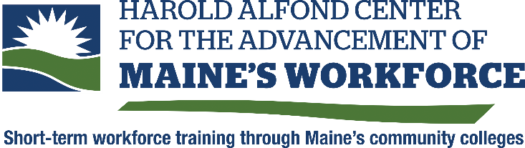

Employee Registration Portal
For Grant Funded Training

Sample language for employer to provide to employees NOT in the sytem

Please note that once an employee who is not in the current system is assigned to a training, they will automatically receive an email. We ask the employer to provide them with the following information to ensure completion of their employee profile.

###

<Organization Name> has received grant funding from the Harold Alfond Center for the Advancement of Maines Workforce, a Maine Community College System division. This grant funding will be used towards training that you will be participating in. The funder requires participant demographic information to meet grant performance metrics for grant reporting. You can expect a few direct communications from the Maine Community College System as a participant. Please be sure to open the emails sent below and follow the instructions.
- Profile Notice from alfondtraining@mccs.me.edu
- This email will provide a link to set up your account and provide the required demographic information. You will only have to do this once.
- Please note: If this step is not completed, your organization will not receive the funding for your training, and your name and email address will be purged from the system.
- Exit Survey from alfondtraining@mccs.me.edu. It is a 3-minute survey about your experience in the training. The results help us measure the quality of the training from a participant’s perspective.
- Follow-up survey from surveys@mccs.me.edu A survey that measures the impact of the training on your employment. This survey is used for grant reporting metrics.

Please note: Your personal data is not detailed in any reporting.

